Goran Magdić
ORS-I (3. godina)

Baze Podataka – Vježba 2 (Priprema)

-- dio 1.1

INSERT INTO CATEGORIES
(CATEGORY_ID, CATEGORY_NAME, DESCRIPTION)
VALUES
(1, 'Elektronika', 'Elektronički uređaji i pribor');

INSERT INTO CATEGORIES
(CATEGORY_ID, CATEGORY_NAME, DESCRIPTION)
VALUES
(2, 'Odjeća', 'Odjevni predmeti i modni artikli');

INSERT INTO CATEGORIES
(CATEGORY_ID, CATEGORY_NAME, DESCRIPTION)
VALUES
(3, 'Knjige', 'Fizičke i digitalne knjige');

-- dio 1.2

ALTER TABLE "PRODUCTS" ADD CONSTRAINT "FK_CATEGORY" FOREIGN KEY ("CATEGORY_ID")
REFERENCES "CATEGORIES" ("CATEGORY_ID") ENABLE;

INSERT INTO PRODUCTS
(PRODUCT_ID, PRODUCT_NAME, PRICE,STOCK_QUANTITY, CATEGORY_ID)
VALUES
(1, 'Kalkulator', 100, 1, 1);

INSERT INTO PRODUCTS
(PRODUCT_ID, PRODUCT_NAME, PRICE,STOCK_QUANTITY, CATEGORY_ID)
VALUES
(2, 'Radio', 100, 1, 1);

INSERT INTO PRODUCTS
(PRODUCT_ID, PRODUCT_NAME, PRICE,STOCK_QUANTITY, CATEGORY_ID)
VALUES
(3, 'Hlače', 100, 1, 2);

INSERT INTO PRODUCTS
(PRODUCT_ID, PRODUCT_NAME, PRICE,STOCK_QUANTITY, CATEGORY_ID)
VALUES
(4, 'Čarape', 100, 1, 2);

INSERT INTO PRODUCTS
(PRODUCT_ID, PRODUCT_NAME, PRICE,STOCK_QUANTITY, CATEGORY_ID)
VALUES
(5, 'Ulaznica', 100, 1, 3);

-- dio 1.3

INSERT INTO CUSTOMERS
(CUSTOMER_ID, FIRST_NAME, LAST_NAME, EMAIL, PHONE, ADDRESS)
VALUES
(1, 'Jovan', 'Jovanović', 'jovan.jovanovic@GMAIL.COM', '999 999', 'Zagreb 1');

INSERT INTO CUSTOMERS
(CUSTOMER_ID, FIRST_NAME, LAST_NAME, EMAIL, PHONE, ADDRESS)
VALUES
(2, 'Goran', 'Magdic', 'goran.magdic@GMAIL.COM', '888 888', 'Zagreb 2');

INSERT INTO CUSTOMERS
(CUSTOMER_ID, FIRST_NAME, LAST_NAME, EMAIL, PHONE, ADDRESS)
VALUES
(3, 'Ivana', 'Ivanović', 'ivana.ivanovic@GMAIL.COM', '777 777', 'Zagreb 3');

-- dio 1.4

INSERT INTO ORDERS
(ORDER_ID, CUSTOMER_ID, ORDER_DATE, TOTAL_AMOUNT, STATUS)
VALUES
(1, 1, sysdate, 10, 'PENDING');

INSERT INTO ORDER_ITEMS
(ORDER_ITEM_ID, ORDER_ID, PRODUCT_ID, QUANTITY, UNIT_PRICE)
VALUES
(1, 1, 5, 1, 100);

INSERT INTO ORDER_ITEMS
(ORDER_ITEM_ID, ORDER_ID, PRODUCT_ID, QUANTITY, UNIT_PRICE)
VALUES
(2, 1, 4, 1, 100);

INSERT INTO ORDER_ITEMS
(ORDER_ITEM_ID, ORDER_ID, PRODUCT_ID, QUANTITY, UNIT_PRICE)
VALUES
(3, 1, 3, 1, 100);

-- dio 2.1

UPDATE PRODUCTS
SET PRICE=10
WHERE PRODUCT_ID=1;

UPDATE CUSTOMERS
SET EMAIL='ivana.ivanovic.gustetic@GMAIL.COM'
WHERE CUSTOMER_ID=3;

UPDATE ORDERS
SET STATUS='SHIPPED'
WHERE ORDER_ID=1;

-- dio 2.2

UPDATE PRODUCTS
SET CATEGORY_ID=2
WHERE PRODUCT_ID=5;

-- ažurirati ORDER_ITEM da referencira nepostojeći PRODUCT_ID
UPDATE ORDER_ITEMS
SET PRODUCT_ID=6
WHERE ORDER_ID=1;
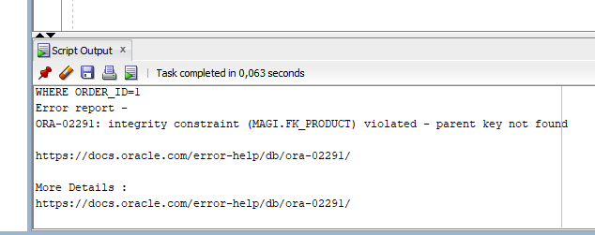

-- dio 3.1

DELETE FROM CUSTOMERS
WHERE CUSTOMER_ID=3;

DELETE FROM PRODUCTS
WHERE PRODUCT_ID=1;

DELETE FROM CATEGORIES
WHERE CATEGORY_ID=3;

-- dio 3.2

DELETE FROM CUSTOMERS
WHERE CUSTOMER_ID=1;

DELETE FROM PRODUCTS
WHERE PRODUCT_ID=5;

DELETE FROM CATEGORIES
WHERE CATEGORY_ID=1;

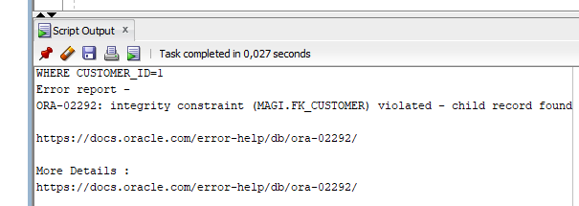

-- dio 4.3

DELETE FROM ORDER_ITEMS
WHERE ORDER_ID=1;

DELETE FROM ORDERS
WHERE ORDER_ID=1;

-- dio 4.4

DELETE FROM PRODUCTS
WHERE CATEGORY_ID=1;

DELETE FROM CATEGORIES
WHERE CATEGORY_ID=1;

-- dio 5.1

INSERT INTO ORDER_ITEMS
(ORDER_ITEM_ID, ORDER_ID, PRODUCT_ID, QUANTITY, UNIT_PRICE)
VALUES
(4, 1, 4, 0, 100);

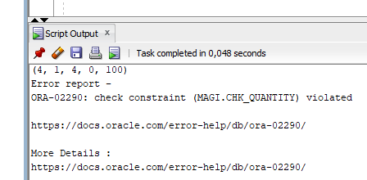

INSERT INTO ORDER_ITEMS
(ORDER_ITEM_ID, ORDER_ID, PRODUCT_ID, QUANTITY, UNIT_PRICE)
VALUES
(5, 1, 4, -1, 100);

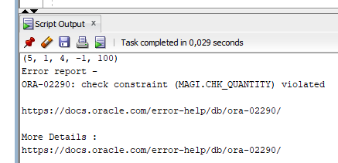

INSERT INTO PRODUCTS
(PRODUCT_ID, PRODUCT_NAME, PRICE,STOCK_QUANTITY, CATEGORY_ID)
VALUES
(6, "Gaće", -1, 1, 2);

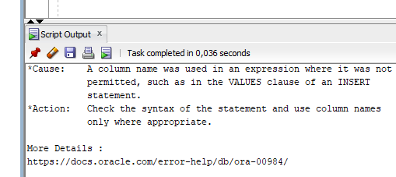

INSERT INTO ORDERS
(ORDER_ID, CUSTOMER_ID, ORDER_DATE, TOTAL_AMOUNT, STATUS)
VALUES
(2, 1, 02.02.2025, -100, "PENDING");

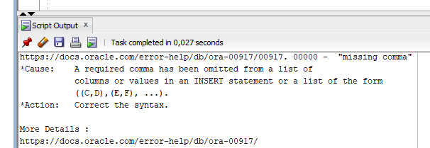

-- dio 6.1

--Namjerno pokušajte prekršiti svako ograničenje stranog ključa i dokumentirajte:
--1. FK_CATEGORY (Products → Categories)
--2. FK_CUSTOMER (Orders → Customers)
--3. FK_ORDER (Order_Items → Orders)
--4. FK_PRODUCT (Order_Items → Products)

INSERT INTO PRODUCTS
(PRODUCT_ID, PRODUCT_NAME, PRICE, STOCK_QUANTITY, CATEGORY_ID)
VALUES
(6, 'cigla', 100, 1, 4);

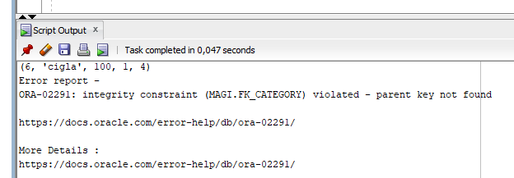

INSERT INTO ORDERS
(ORDER_ID, CUSTOMER_ID, ORDER_DATE, TOTAL_AMOUNT, STATUS)
VALUES
(3, sysdate, 100, "PENDING");

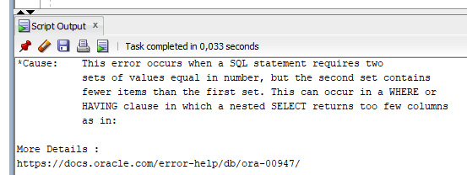

INSERT INTO ORDER_ITEMS
(ORDER_ITEM_ID, ORDER_ID, PRODUCT_ID, QUANTITY, UNIT_PRICE)
VALUES
(6, 10, 4, 1, 100);

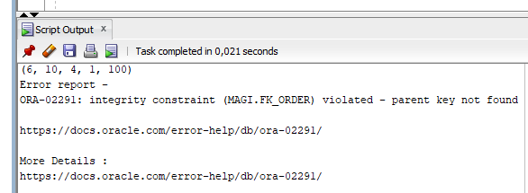

INSERT INTO ORDER_ITEMS
(ORDER_ITEM_ID, ORDER_ID, PRODUCT_ID, QUANTITY, UNIT_PRICE)
VALUES
(6, 1, 10, 1, 100);

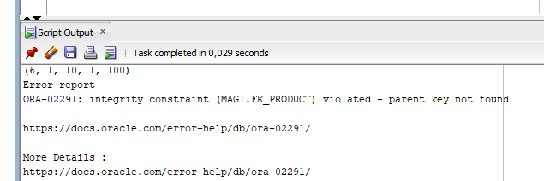

-- dio 6.2

-- 1. Onemogućite ograničenje stranog ključa

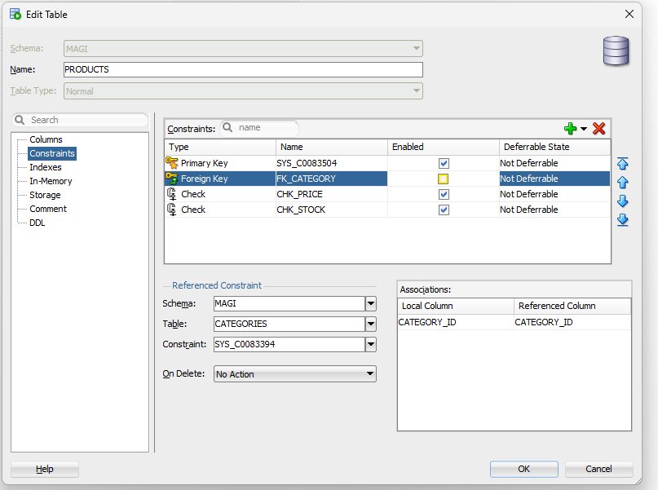

-- 2. Umetnite nevažeće podatke

INSERT INTO PRODUCTS
(PRODUCT_ID, PRODUCT_NAME, PRICE, STOCK_QUANTITY, CATEGORY_ID)
VALUES
(6, 'cigla', 100, 1, 4);

-- 3. Pokušajte ponovno omogućiti ograničenje

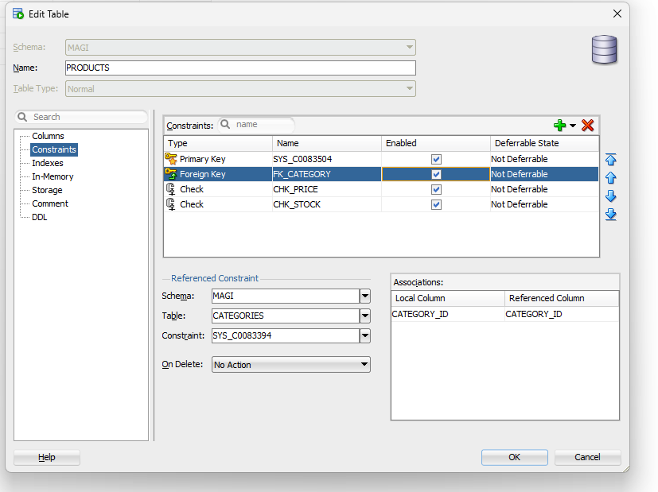

-- 4. Dokumentirajte što se događa i kako to popraviti

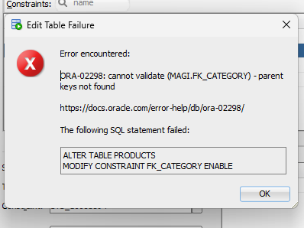

UPDATE PRODUCTS
SET CATEGORY_ID=3
WHERE PRODUCT_ID=6;

